Practical-3:
Design responsive layouts for Home, About, Registration, Dashboard, and
Events pages using CSS Grid and Flexbox. Optional to use CSS
framework such as Bootstrap or Tailwind. Ensure mobile-first
responsiveness.
Screenshots:
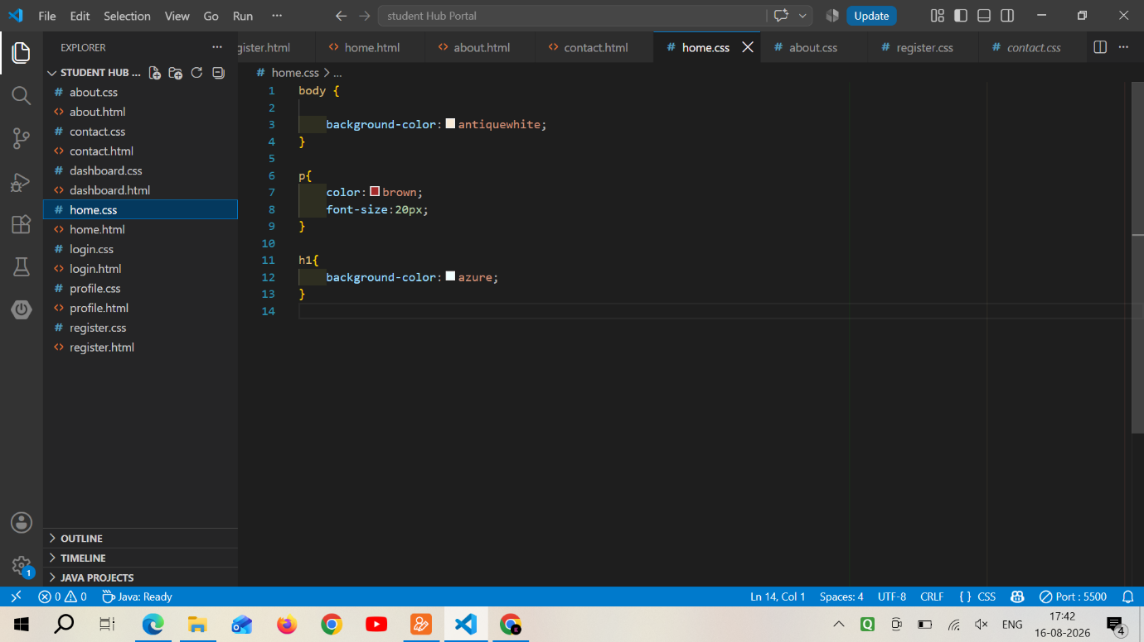

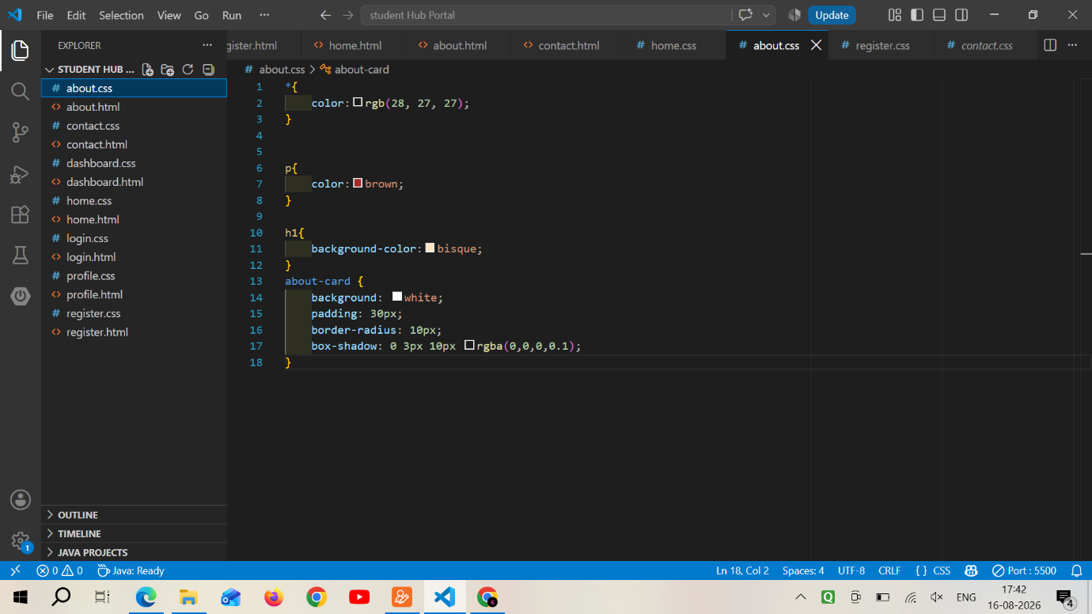

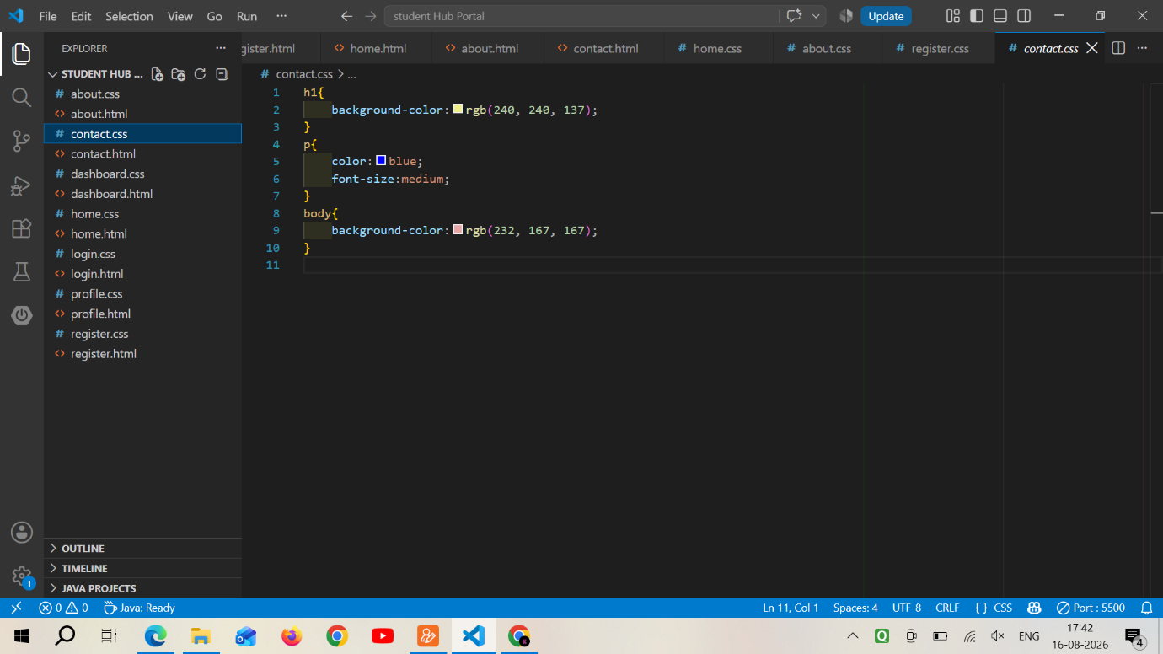

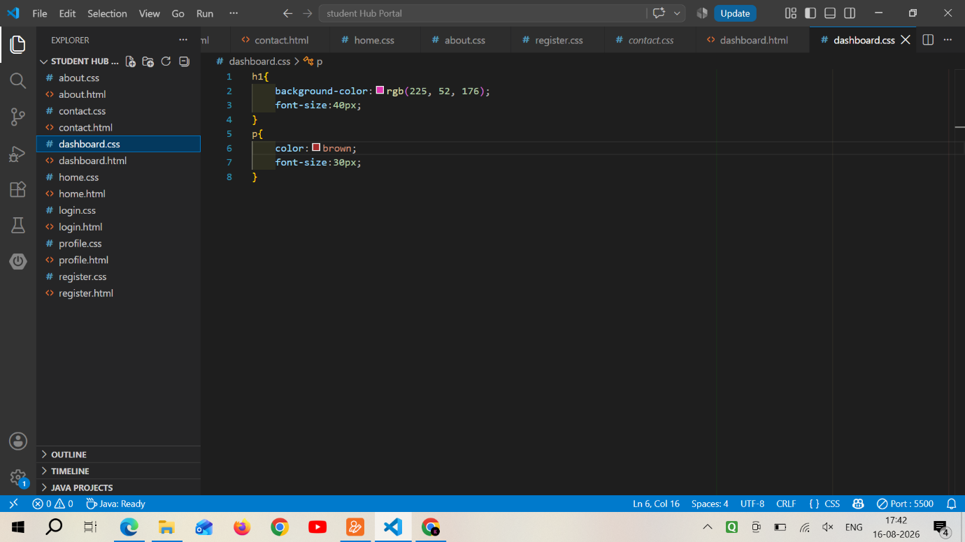

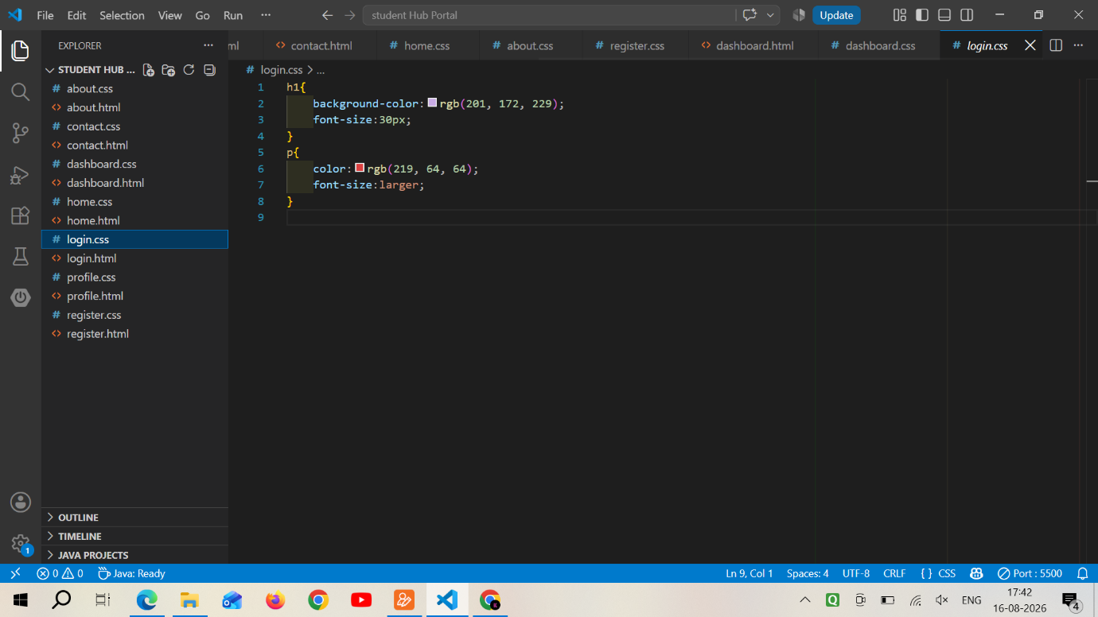

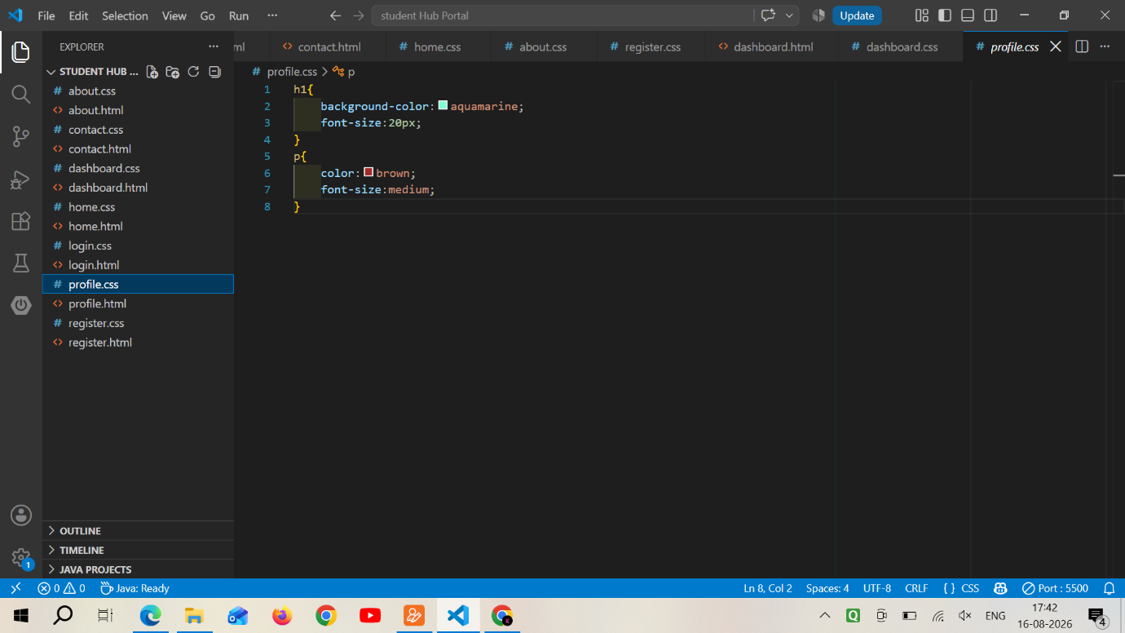

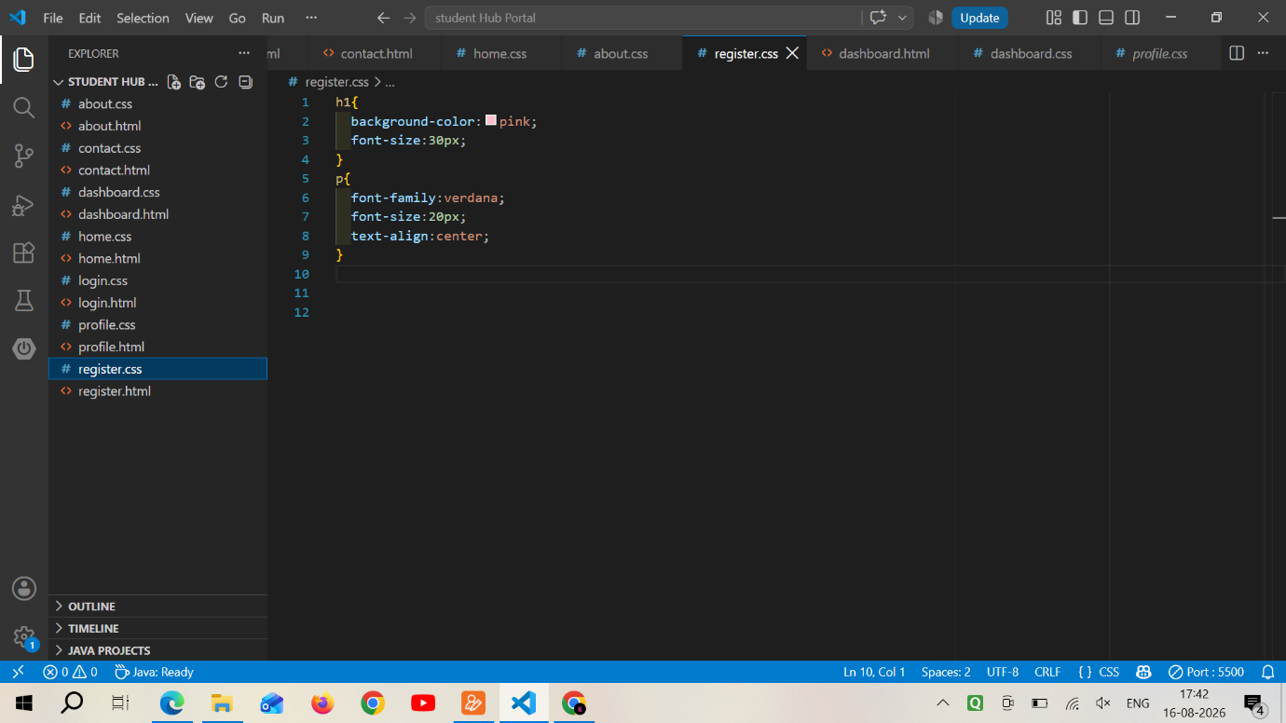
Learning:
Code used in making css .
Looks changed after applying css style to the html web page.

